
Corporate Policy

Traffic Management Arrangements

September 2026 – August 2027

TRAFFIC MANAGEMENT ARRANGEMENTS AT
Blaenhonddan Primary School
from September 2026

Contents

Section

1. Introduction

2. Layout / Access

3. School Opening / Closing times

4. Minibus and Bus management on and around the site
- Minibuses and Buses on site
- Minibuses and Buses on curtilage of site
- Staff supervision

5. Vehicles at school site
- Vehicles on site
- Parents vehicles
- Staff vehicles
- Senior Staff / Sixth Form
- Visitors
- Contractor’s vehicles
- Building works vehicles
- Servicing / Deliveries
- Buses, Mini Buses and Taxis
- Emergency Access

6. Pedestrians at school site

7. Parking

8. Cycles

9. Pupils

10. Footways

11. Access to and from school

12. Split sites

13. Shared sites

14. Physical Control Measures
1. Introduction
This document has been prepared to inform and instruct employees, pupils, parents and others who come onto the site, including visitors (both pedestrians and people in vehicles), about the site rules concerning pedestrian and vehicle separation.
Blaenhonddan Primary School takes the health and safety of all site users very seriously. It is therefore imperative that individuals, when in the school grounds or within the vicinity of the school grounds, take care, exercise caution and follow instructions to avoid risk of injury. If there are any concerns about traffic safety, they should be reported to the school leadership team.
We urge all site users to read this document carefully and act in accordance with the instructions contained therein. The instructions constitute site rules. Pupils in breach of the site rules may be subject to disciplinary action.
Copies of the traffic management arrangements are also available from reception and on the school website: Office@blaenhonddanprimary.npt.school
The document will be reviewed annually and awareness raised regularly through parental events, pupil sub-groups, assemblies and school meetings.
For further information, please contact:

Mrs Gayle Major – Headteacher Miss Marie Baker – ALNCO
Tel number: 01639 644366
Email address: MajorG4@Hwbcymru.net BakerM247@Hwbcymru.net

2. Layout / Access

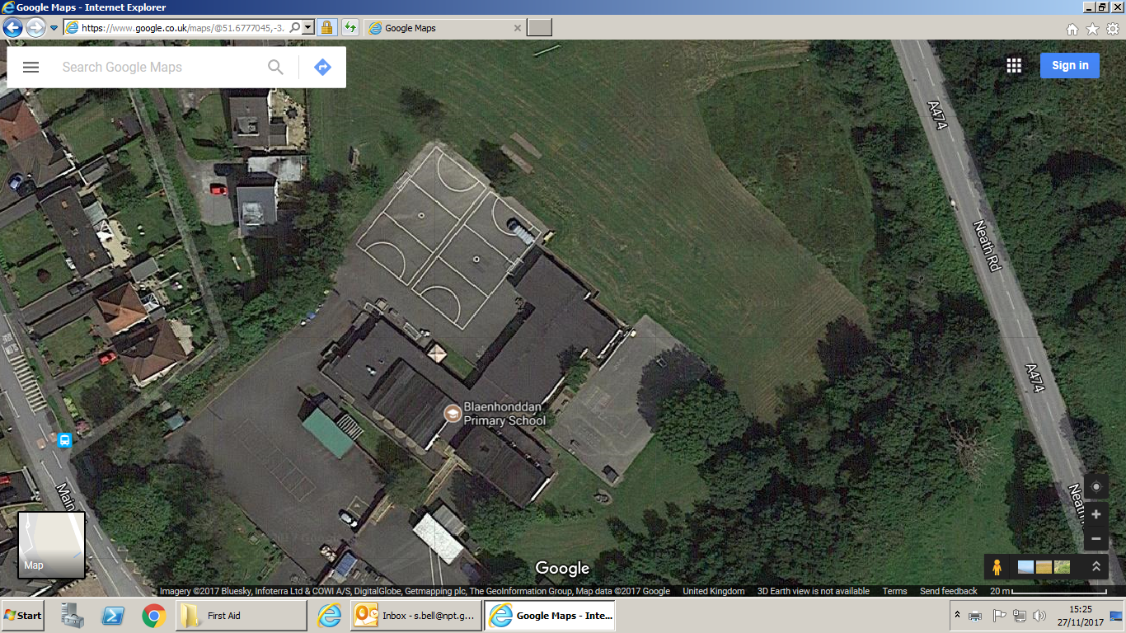
Main Road
Neath Road

Car Park Entrance Car Park Main School Entrance

3. School Opening / Closing times

School is open 8.45 am until 3.30pm. Registration is from 8.45am to 9am and 1pm to 1.05 pm
Breakfast Club starts at 8.15am and finishes 8.45am. Door closes at 8.30am
Nursery am is 9.00 am until 11.30am
Nursery pm is 1.00pm until 3.30pm

4. Minibus and Bus management on and around the site

Minibuses and Buses on site:

There are no minibuses or buses kept on site.

Minibuses and Buses on curtilage of site:

There are 6 minibuses and 3 cars driven by parents, which arrive at the school site dropping off and picking up children from the 3 Learning Support Centre’s.
The arrival and departure times are between 9:00am to 9:10am and 2:50pm and 3:10pm.

Staff supervision

Staff supervise pupils’ arrival and departures via transport from 8:55am until 9:10am and dismiss children between 3:00pm and 3:10pm. The rest of the school arrive at 8:50am and leave between 3.20pm – 3:30pm in the afternoon.

All vehicles must come to a stop before any child dismounts from the transport. Once it is safe, staff with high visibility clothing will collect the children from the taxis. All other staff will wait behind the gates. Children will be handed over to staff behind the gates so that they can make their way to classes immediately.
Children must not wait upon arrival.

Departure – All classes will congregate on the yard at 2:55pm for 3pm departure. Staff will dismiss children in order of the transport provider. Staff will walk children to the available transport and when all children are safe within the transport and the car park is sterile, can vehicles move.

Any incidents regarding pupil safety must be reported to Marie Baker, who will make changes or inform the headteacher.

Staff supervision location & timings at start / end of school day

A member of staff will be located at the main reception door to the hall in the morning from 8:15am to supervise the arrival of breakfast club pupils.
Teaching staff will wait at the top of the steps by the front yard between 8:45am and 9:00am, to supervise pupils arriving at the start of the school day.
All classes will be dismissed via the main entrance of the school from 3:20pm.

5. Vehicles at school site

All vehicle drivers authorised to enter the site must be informed of the need to exercise extreme caution during access and egress.

Vehicles on site

Authorised visitors are welcome to park in the school grounds. The car park is often busy, however visitors should only park in available designated bays. Doing so will allow unrestricted movement of other vehicles during the school day or at peak times. The car park gates will be locked from 8.30am in the morning and will be opened at 9.00am. The gates will be closed all day, but opened at 3.00pm.
The gates will be locked at 3:10pm until 3:30pm.
If staff / visitors need to use the car park outside of these times, then they must open and shut the gates. There is strictly no entry into or out of the car parks between 8.30am and 9.00am and 3.10pm and 3.30pm.
Alternative on street parking is available in the surrounding area, but if you are unfamiliar with the area, please make sure that you do not block residential driveways or park where this could cause an obstruction.

Parents’ vehicles
Parents / Guardians are not permitted to bring vehicles into the school compound unless they have an arrangement with the Headteacher.

Staff vehicles

To avoid unnecessary vehicle congestion, members of staff that drive to work, are requested to arrive on site by 8.30am, prior to the locking of the school gates.

School staff may leave after 3.30pm.

Staff must park in the allocated car park only and should take care not to obstruct any access routes. Drivers should proceed slowly within the car park at all times. Please bear in mind that some young people and some pupils with additional support needs may have little or no awareness of road safety and you should take account of this. Staff are expected to act responsibly on the site when parking and accessing the school building. It would be helpful if staff could supply the school with their registration number so that you can be contacted if there is a need to do so.

Visitors

Visitors may park in the car park in a designated parking bay. Visitors should exercise extreme caution when driving on the school grounds. In order to protect pupils and pedestrians from traffic movement, there will be no access or exit from the Staff / Visitor Car Park between 8.30am and 9am and from 3.10pm and 3.30pm on any school day. Any late arrivals or visitors wishing an early exit, outside the school start / close times, are advised to park outside the school grounds because gates will not be opened.

All visitors must report to reception and sign in before going anywhere in the school. Visitors are required to leave a note of their registration number with staff. On departure, visitors should sign out at reception and leave the building by the main entrance door.

There are also disabled parking bays available.

If visitors need any advice on access or parking before their visit, please call the school reception on 01639 644366.
Contractor’s vehicles
Contractors should arrange to visit the site by appointment and they must be informed not to arrive or depart at the start/end of the day or break/lunchtime.
Building works vehicles
Where significant works are proposed the vehicle access and working arrangements must be discussed and agreed at the feasibility stage between Headteacher and Contractor.
Where possible, arrangements should be made to dedicate one particular vehicle entrance for construction traffic only. If this is not possible then the time the construction vehicles enter site needs to be agreed with the Head Teacher and closely supervised by a banksman.
The amended site access arrangements need to be recorded and communicated to all site users.

Servicing / Deliveries

Drivers of service vehicles (if they have not been on the site before or obtained instruction in advance) should report to the reception desk at the main entrance. Drivers may be issued with a copy of this plan for reference or simply be advised of the site rules in relation to the area they are parking at the time.

Where the contractor is on site to carry out works by prior arrangement, please call the school reception on (01639 644366) in advance, to agree the most suitable parking location.

If applicable to your school: All vehicles must enter using the main gate and follow the one way system around the car park.

Service vehicles do not have access to the car park or delivery area between 8:30am and 9:00am and 3:00pm to 3:30pm.

Taxis

The school is accessed via Main Road. Taxis must enter and leave school by the designated entrance / exit.

Drivers of taxis are required to park responsibly within the car park. The school displays clear 5mph speed limit signs, which should be respected by all road users.

Emergency Access

If a vehicle has to be driven through the playground it should be done when the playground is free from pupils. If this is not possible due to exceptional circumstances, then vehicles should be driven slowly through the playground whilst sounding the horn and activating their hazard warning lights to alert all in the area. A nominated person should clear the vehicles route in advance.

6. Pedestrians at school site

In order to ensure that the car park has no moving vehicles, the following control measures have been put into place during drop-off and pick up times.

- Gates will be closed between 8:30am and 9:00am
- Gates will be closed between 3:00pm and 3:30pm
- A member of staff will be present in the car park / at school gates to ensure there is no movement of traffic

All pedestrians must enter / exit the campus from the main pedestrian entrance. Entrance to the car park is not permitted under any circumstances. There will be no movement of cars between 8:30am and 9:00am and between 3:10pm and 3:30pm.

Pedestrians should make sure that they use routes safely and avoid spilling onto the road. Pedestrians walking in groups should take this into account and allow other users to pass safely.

Pedestrians should only access the school from the designated entry points.
Pedestrians NOT permitted to use the car park entrance as an access/egress route. Signs are displayed on the school gate.

7. Parking

A regular review of parking arrangements is undertaken to consider if:-
- The parking spaces are in appropriate places
- The position of the spaces hinders access to/egress from the building.
- Vehicles have to cross pedestrian routes to access them.
- The route allows suitable access for emergency vehicles.
- The parking area is in a suitable condition.
- Arrangements are in place for visitor parking.
- Arrangements are in place for disabled parking.
- Vehicles must give way to pedestrians at designated crossing points.

8. Cycles

Cyclists must dismount before entering the school premises and park in the cycle shelters or in the agreed location.

9. Pupils

Pupils are made aware that parking areas are out of bounds. Pupils must not be asked to collect or carry things from staff vehicles unless a member of staff accompanies them. Pupils must not be allowed to open/close the school gates to allow vehicles access/egress.

10. Footways

Pedestrian footways must be maintained in good condition. They must be free from obstruction, overhanging vegetation and moss. Footways which are in poor condition may result in tripping accidents or pedestrians may be put at risk by walking on the road to avoid them.

11. Access to and from school

The school suffers from severe vehicle congestion problems close to and surrounding the premises. Parents who drop off and pick up their children by car, cause much of the congestion.
The school considers the following, in an attempt to reduce the congestion:
- Encourage walking and cycling by collaborative work with the Road Safety Team and to involve pupils in education and safety initiatives.
- Liaise with local Police/Parking Attendants regarding enforcement.
- Revise the travel plan annually.
- Remind parents from time to time of the dangers and problems associated with congestion at school entrances.
- Parents should also be encouraged to car share to reduce the number of vehicles outside the site.
- Liaise with operators who pick up/drop off pupils transported by bus/taxi.
- To liaise with the Local Authority regarding remedial measures (speed limits, road marking, traffic calming etc.).
- To ensure that a record of traffic incidents that occur off site in the vicinity of the school is maintained.
12. Split sites
This school is only on one site.
13 Shared sites
This school does not have a shared site.

14. Physical Control Measures

Signage

The installation of appropriate signage needs to be considered such as: -
- Speed limit signs (5mph).
- Warning notices at entrances stating that only authorised vehicles are permitted on site.
- Warning notices highlighting that children could be at play and the need to exercise caution.
- Signage indicating the route to the car park.
- Signage indicating where deliveries are to be made.
- Signage to close the gates after entering and leaving.
(Signs used in connection with traffic should where possible comply with the Highway Code).

Speed humps

There are no speed bumps on site.

Fencing

Fencing and gates provide a barrier to the car park and the main roads.

Road markings

The headteacher is in discussion with the LA to add road markings to the school grounds September 2025.

Where pedestrians share the same access as vehicles it is advisable to permanently mark the route on the ground.

Where the pedestrian route crosses the vehicular traffic the provision of a safe road crossing should be marked on the ground (zebra crossing).

Where buses, minibuses or taxis are brought onto site the bus bays/parking area should be marked out on the ground. This could help reduce the likelihood of anyone else parking in these areas.

Gates

Gates are shut between 8:30am and 9:00am.
Gates are closed between 3:00pm and 3:30pm.

Poor visibility

Teaching staff who enter the car park to collect pupils from vehicles will wear high visibility clothing during the winter months.

Where the visibility is poor then the following must be considered: -
- Is there adequate lighting for traffic routes and footpaths?
- Have staff undertaking supervisory roles been provided with high visibility waistcoats?
- Encourage pupils to carry/wear reflective safety products/clothing.
- The use of mirrors at a blind corner/bend can enable pedestrians and drivers to view around the corner/bend.
- Appropriate signage
- Features including speed cushions to reduce traffic speed where visibility is obstructed by buildings, road layouts etc.

Date Reviewed | Signed | Approved by GB Name and Date
04.09.25 | G. Major
01.09.26 | G. Major

