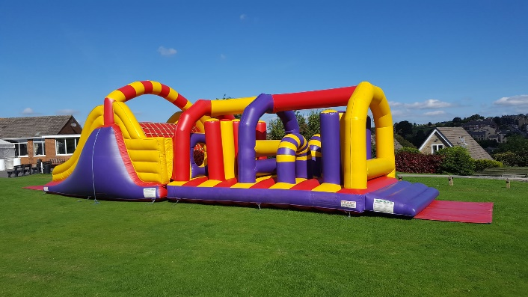
Fab’S Fun day Wednesday 19th July

FAB Fun Day event during school on Wednesday 19th July. The event will cost £5 and will include time on an inflatable assault course, other fun games/activities, tip tops and the option to have a small face painting or a painted tattoo. The event is on Parent Pay. We hope this will be a fun event that the kids will enjoy as well as raising some money for the school.




